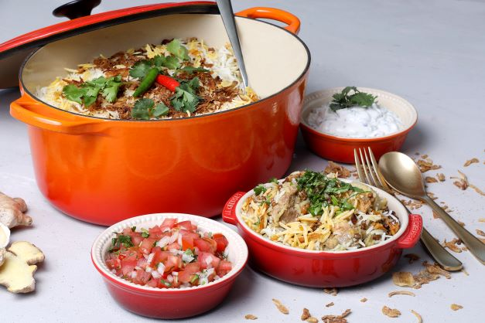

Mutton biryani
Makes: 8 servings
Prep time: 50 minutes
Cooking time: 3 hours

Ingredients:
90ml (6 tablespoons) ghee
2 medium onions, peeled and sliced
1.5kg mutton pieces with bone in
2.5ml (½ teaspoon) saffron
5ml (1 teaspoon) grated ginger
2 cloves garlic, crushed
250ml (1 cup) sour milk
30ml (2 tablespoons) fresh grated tomato
5ml (1 teaspoon) cumin powder
2.5ml (½ teaspoon) turmeric
10ml (2 teaspoons) salt
5ml (1 teaspoon) coriander powder
7.5ml (1 ½ teaspoons) crushed red chilli
4 green chillies
2 sprigs mint
500ml (2 cups) Golden Delight Extra Long Grain 1121 Sella Basmati rice
4 cardamom pods
2 sticks cinnamon
6 small potatoes, peeled and halved
2 x 400g cans of lentils, rinsed and drained

Method:
- Fry the sliced onions in half the ghee or oil until pale golden. Drain and cool.
- Leave aside 1 tablespoon of fried onions.
- Place the meat in a large bowl. Add the saffron, ginger and garlic, sour milk, grated tomato, spices, remaining fried onions, whole green chillies and mint and leave to marinate for 1 hour.
- Boil the Golden Delight Basmati Rice with 2 cardamom pods and 1 cinnamon stick until half cooked and drain.
- Peel the potatoes and cut each potato in 6. Fry the potatoes until light yellow in the ghee used for frying the onions. Set aside.
- In a large flat-bottomed pot, add the ghee used for frying and the half that was kept aside and gently heat.
- Sprinkle a handful of rice and lentils over the base of the pot.
- Arrange the marinated meat and masalas carefully over the rice and lentils.
- Spread the remaining lentils over the meat.
- Arrange the potatoes on top of the lentils, then spread the rice on top.
- Decorate with the fried onions that were set aside, sprinkle with any remaining ghee and 125ml water.
- Close the pot and turn up the heat and simmer for 5 minutes. Reduce the heat to low and simmer for 30 minutes.
- Place the covered pot in the oven at 160C for 2 ½ hours.
- Serve with a sprinkle of fresh coriander and serve with sambals and raita on the side.

Tips:
- Mutton is a fattier meat that is not so tender, but the lengthy duration of this biryani cooking time ensures that it is tender and delicious once cooked. Replace with beef or chicken for a lower fat alternative.
- The addition of lentils not only provides more protein but also boasts complex carbohydrates and fibre. The layering of the rice in the dish soaks up the flavour and cooks within the sauce, also ensuring that each serving provides a balance of the contents of the dish.
- While ghee is integral in the traditional make up of this dish, to reduce fat, fried potatoes can be made in an air fryer or baked in the oven.

